**Capstone Project**

**The Battle of**

**Neighborhoods**

**Introduction:**

Being fond of food, when it comes to find out a solution to a problem using data science, the first thing that comes to my mind is why not help my own community of foodies ☺, which eats and serves delicious food to all. This project can help people who want to open a restaurant like Burrito Place. In this project they can find the process to find the best location using different tools and data science.

**Background:**

Business is not an easy business, and investment makes it even worse. When you know that you are going to spend your valuable money on something, you eventually hope that it will return back you something of greater value. This project will help to choose a correct location to open Burrito Place like something in Ontario, Canada

**Problem Statement:**

This project will pupil to find the best location to open a Burrito Place in Ontario, Canada. Firstly, it is important to know each Borough to select the best with low competition and high potential clients.

Then, is important know the neighborhood and finally select the best location.

**Data Collection:**

I will use List of postal codes of province of Ontario, Canada from the following link in Wikipedia: [https://en.wikipedia.org/wiki/List_of_postal_codes_of_Canada:_M,](https://en.wikipedia.org/wiki/List_of_postal_codes_of_Canada:_M) it contains 10 borough in Ontario.

I will use the Google Maps Geocoding API to get the latitude and the longitude coordinates of each

Borough and neighborhood in Ontario. After, I will use Foursquare API to get the information about Borough and neighborhood and I will perform analysis of this.<http://cocl.us/Geospatial_data>

**Methodology:**

* Collect postal codes of province of Ontario,Canada from the following link in Wikipedia:

https://en.wikipedia.org/wiki/List_of_postal_codes_of_Canada:_M

* Use the Google Maps Geocoding API to get the latitude and the longitude coordinates of each Borough and neighborhood in Ontario
* Using FourSquare API to find venues for each neighborhood.
* Find the borough with greater amount of burrito places (biggest potential customers)
* Find neighborhood no burrito places and large number of stores

**Results:**

First, neighborhoods in Ontario:

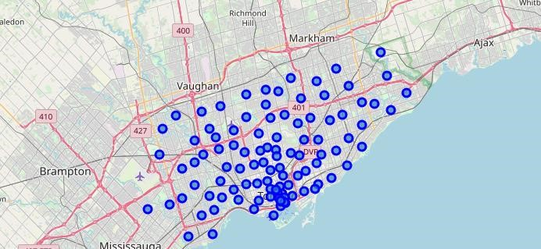

Find the borough with greater amount of burrito places (biggest potential customers):

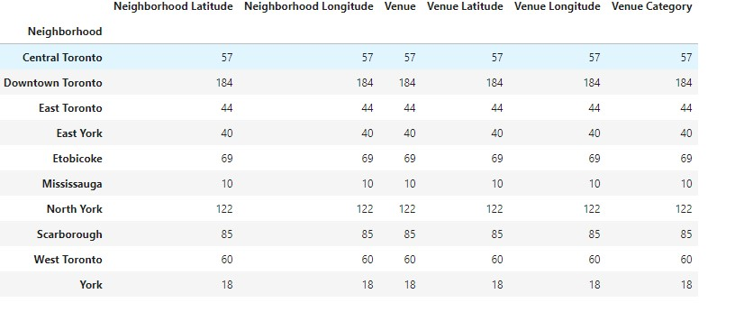

The borough with greater amount of burrito places (biggest potential customers) is Scarborough with large number of restaurants but only 5 burrito places:

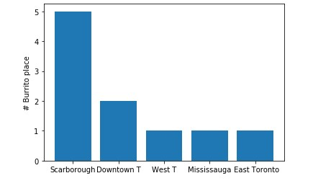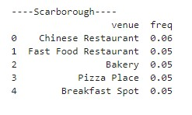

Now, find a neighborhood in scarborough no burrito places and large number of stores(biggest potential customers):

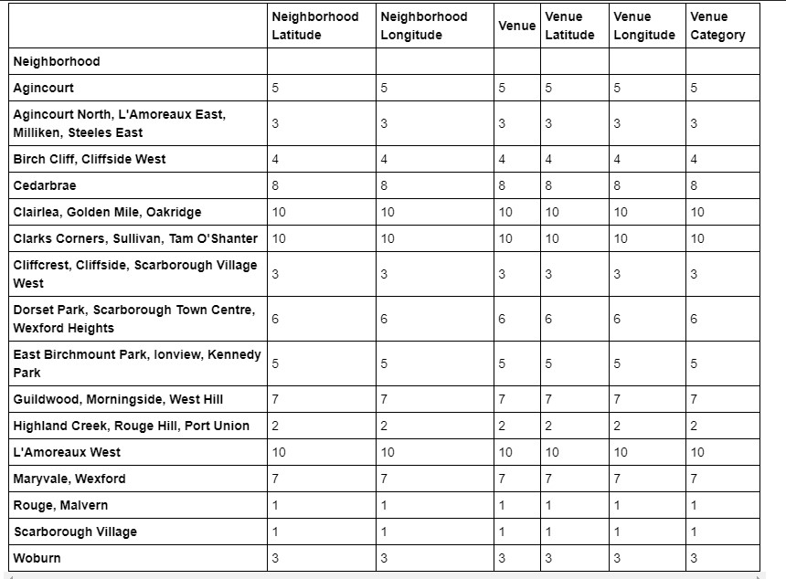

Next, use cluster to reduce the number of options:

Cluster1:

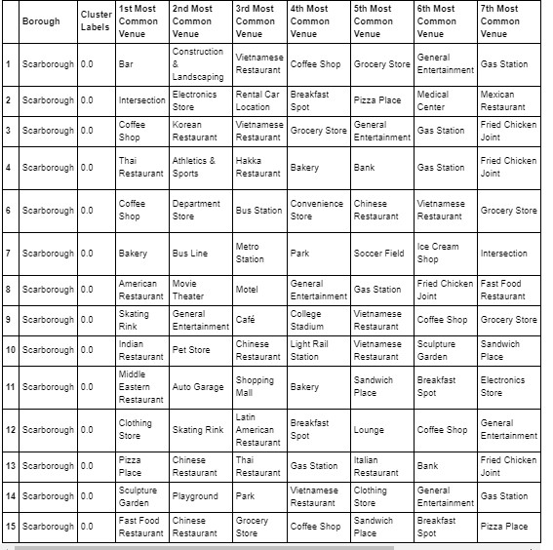

Cluster2:

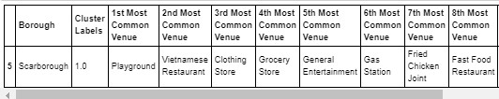

**Discussion:**

According to the results the best place to open a Burrito place is the cluster 1, the neighborhood is Scarborough Village, it has a large number of stores and restaurants different to Burrito Place.

**Conclusion:**

* Scarborough have potential Burrito Market
* The project depends of the accuracy of the foursquare data